Apply for Jira project, please answer the following 8 questions in your SBM case.
- What will be your project name? (Please check the full project name on PRS)

- What will be your project category (Pick one category from the following table)?
Project Category | Description
NONPRS Dep. Task Management | not registered in PRS and is about Dep. Task management
NONPRS Software Development | not registered in PRS and is about software development
PRS Backend Services | Registered in PRS and belong Backend Services
PRS Module Development | Registered in PRS and belong Module Development
PRS Others | Registered in PRS and can't group into current categories
PRS Product Development | Registered in PRS and belong Product or Service Development
PRS Product/Service Sustain | Registered in PRS and belong product or service maintenance

- Who will be your main JIRA project administrator (system –level)?

- Please provide your options and default value for “Platform” field-
(Sample value: windows, Linux, Android 4.4 (Default), IOS 6.0 )
- Please provide your options and default value for “Platform Language” field-
(Sample value: en-gb(English-UK) , jp (Japan))

- Will your project be accessed by L10N team, outside OEM partner or External Contractor?
(Yes/No)

- Which issue type scheme you want to have in your Jira Project?
- (Standard) TM Bug Issue Type Scheme:
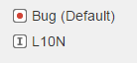
- (Standard) TM Dev Issue Type Scheme:
Bug/L10N/Epic/Story/Sub-task
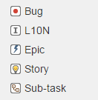
- (Standard) TM Sustain/OP Issue type Scheme:
Bug/L10N/Question/Incident/New Feature/ Enhancement / Task/ Sub-task
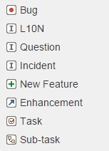

- Which workflow you want to have for Bug Issue type?
(a) Traditional workflow like SBM.
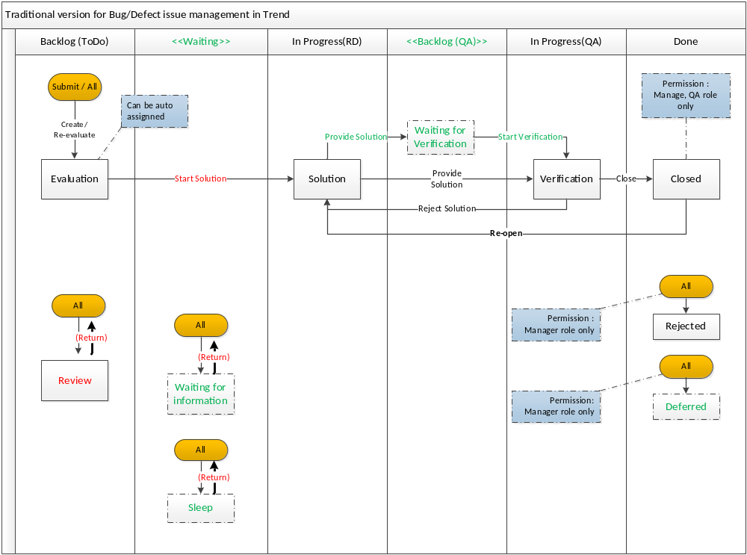
(b) Simple workflow with “Waiting for verification” Status.
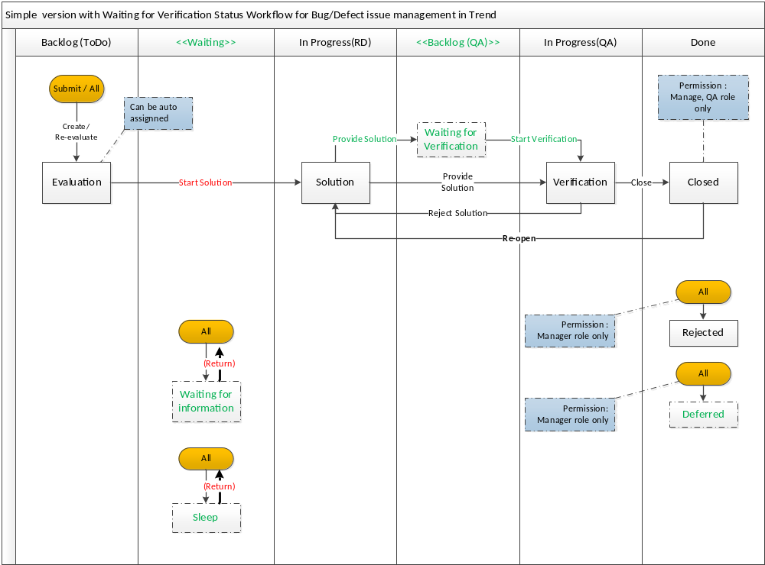
(c) Simple workflow without “Waiting for verification” Status.
